MediPal

Use-Case Specification

Version 1.0

Revision History

| **Date** | **Version** | **Description** | **Author** |
| --- | --- | --- | --- |
| 15/06/2025 | 1.0 | Initial draft of Use-Case Specification for MediPal, including full set of 18 use cases for both **Primary User** and **Caregiver**, based on updated Vision Document. | Toan, Luong |

Table of Contents

**1. Use-case Model 4**

**2. Use-case Specifications 4**

2.1 Use-case: Register 4

2.2 Use-case: Log in 5

2.3 Use-case: Log out 6

2.4 Use-case: Manage Profile 6

2.5 Use-case: Create Medication Schedule 7

2.6 Use-case: Create Appointment Schedule 7

2.7 Use-case: Create Healthcare Reminder 8

2.8 Use-case: Record Medication Dose 8

2.9 Use-case: View History Log 9

2.10 Use-case: Customize Reminders 9

2.11 Use-case: Use AI Chatbot 10

2.12 Use-case: Manage Caregiver Access 10

2.13 Use-case: Register (Caregiver) 11

2.14 Use-case: Log In (Caregiver) 11

2.15 Use-case: Log Out (Caregiver) 12

2.16 Use-case: Accept/Decline Invitation 12

2.17 Use-case: View Shared Schedule 13

2.18 Use-case: Receive Missed Dose Alert 14

# Use-case Model

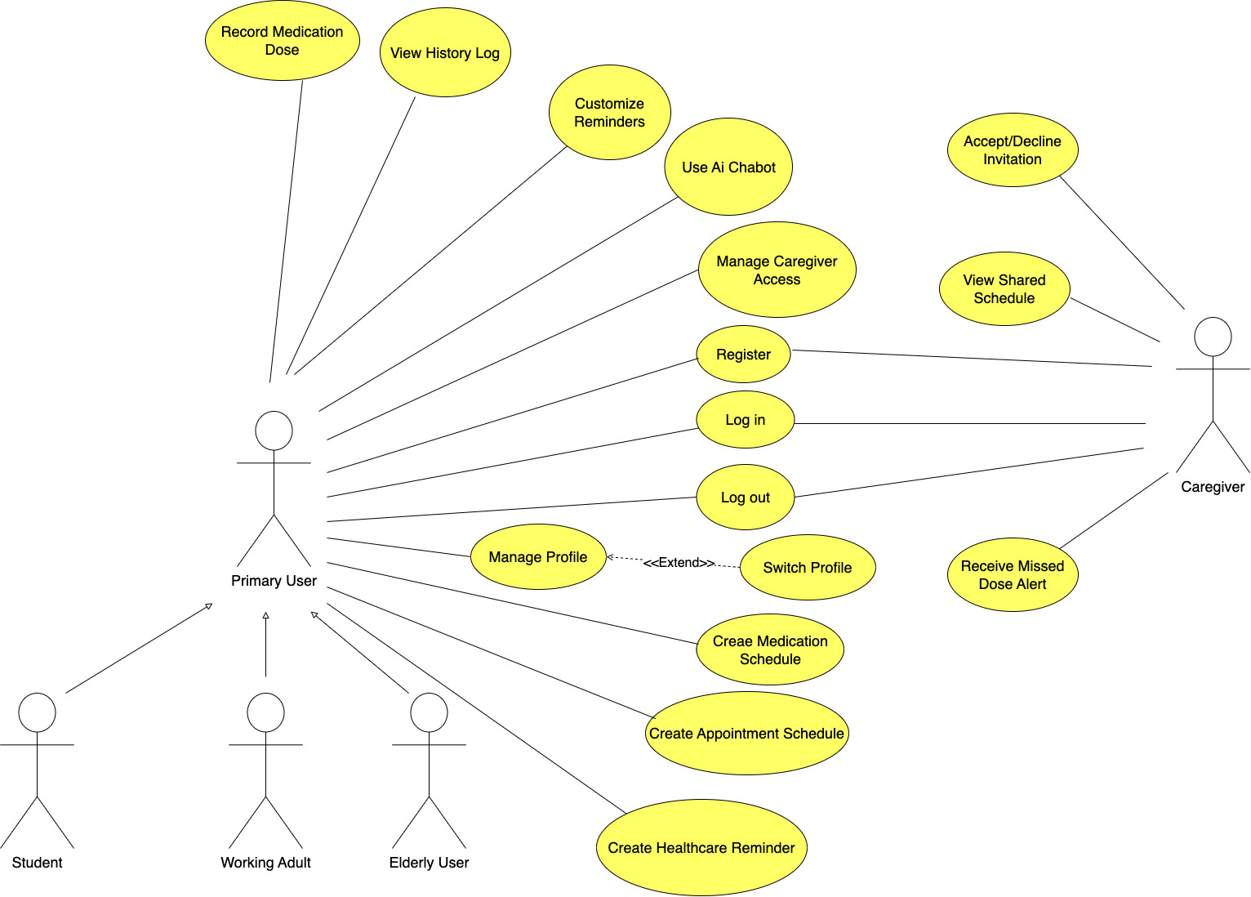

# Use-case Specifications

## Use-case: Register

| Use case Name | Register (UC01) |
| --- | --- |
| Brief description | Allows a new user to create a Primary User account in the MediPal system. |
| Actors | Primary User (prospective) |
| Basic Flow | 1. User selects the "Register" or "Sign Up" option.  2. System displays the registration form.  3. User enters required information (e.g., email, password, name).  4. User accepts the Terms of Service.  5. User clicks the "Register" button.  6. System validates the input data (e.g., checks if email is unique, password meets complexity rules).  7. System creates a new user account.  8. System automatically logs the user in and navigates them to the main dashboard. |
| Alternative Flows | **Alternative Flow 1: Email already exists**  1. At step 6 of the basic flow, the system detects the email is already registered.  2. System displays an error message: "This email address is already in use. Please log in or use a different email."  3. The flow resumes at step 3. |
| Pre-conditions | The user does not have an existing account and is on the application's welcome/login screen. |
| Post-conditions | A new Primary User account is created and stored in the system. The user is logged in. |

## Use-case: Log in

| Use case Name | Log In (UC02) |
| --- | --- |
| Brief description | Allows a registered Primary User to access their account. |
| Actors | Primary User (prospective) |
| Basic Flow | 1. User enters their registered email and password.  2. User clicks the "Log In" button.  3. System validates the credentials.  4. System establishes a secure session.  5. System displays the user's main dashboard. |
| Alternative Flows | **Alternative Flow 1: Invalid credentials**  1. At step 3 of the basic flow, the system determines the email/password combination is incorrect.  2. System displays an error message: "Invalid email or password."  3. The flow resumes at step 1. |
| Pre-conditions | The user has an existing account and is not currently logged in. |
| Post-conditions | The user is successfully authenticated and has access to their application data. |

## 

## Use-case: Log out

| Use case Name | Log Out (UC03) |
| --- | --- |
| Brief description | Allows a logged-in Primary User to securely end their session. |
| Actors | Primary User (prospective) |
| Basic Flow | 1. User selects the "Log Out" option from the menu or profile page.  2. System terminates the user's session.  3. System clears any sensitive session data.  4. System navigates the user back to the login screen. |
| Alternative Flows | **Alternative Flow 1: Network connection lost during logout**  1. At step 2 of the basic flow, the system attempts to notify the server of the logout but fails due to a network error.  2. System proceeds to terminate the local session and clear sensitive data on the device (as per steps 3 and 4).  3. The server-side session will eventually time out. |
| Pre-conditions | The user is currently logged in. |
| Post-conditions | | The user's session is ended, and they can no longer access protected content without logging in again. | | --- | |

## Use-case: Manage Profile

| Use case Name | Manage Profile (UC04) |
| --- | --- |
| Brief description | Allows a Primary User to view and update their personal information. |
| Actors | Primary User (prospective) |
| Basic Flow | 1.User navigates to the "Profile" section.  2. System displays the user's current profile information (name, date of birth, etc.).  3. User selects an "Edit" option.  4. User modifies the desired information.  5. User clicks "Save".  6. System validates and saves the updated information.  7. System displays a confirmation message. |
| Alternative Flows | **Alternative Flow 1: User cancels editing**  1. At any point before step 5, the user selects the "Cancel" or "Back" button.  2. System discards any unsaved changes.  3. System returns the user to the profile view screen.  **Alternative Flow 2: Invalid data input**  1. At step 6 of the basic flow, the system validation fails (e.g., user enters text in a date-of-birth field).  2. System displays an error message next to the invalid field.  3. The flow resumes at step 4, allowing the user to correct the data. |
| Pre-conditions | The user must be logged in. |
| Post-conditions | The user's profile information is updated in the system. |

## Use-case: Create Medication Schedule

| Use case Name | Create Medication Schedule (UC05) |
| --- | --- |
| Brief description | Allows the Primary User to set up a new medication schedule. |
| Actors | Primary User (prospective) |
| Basic Flow | 1. User navigates to the 'Schedules' screen and selects 'Add Medication'  2. System displays the 'New Medication Schedule' form.  3. User enters medication details (name, dosage, form).  4. User sets the schedule frequency and specific times.  5. User sets start and end dates.  6. User clicks 'Save'.  7. System validates the data.  8. System saves the new schedule.  9. System displays a success confirmation. |
| Alternative Flows | **Alternative Flow 1: Invalid data**  1. At step 7, if data is invalid, the system highlights the incorrect fields and shows an error message.  2. The flow resumes at step 3. |
| Pre-conditions | The user must be logged in. |
| Post-conditions | A new medication schedule is created. Reminders for this schedule are activated. |

## Use-case: Create Appointment Schedule

| Use case Name | Create Appointment Schedule (UC06) |
| --- | --- |
| Brief description | Allows the Primary User to add a new doctor's appointment to their calendar. |
| Actors | Primary User (prospective) |
| Basic Flow | 1. User navigates to the 'Appointments' screen and selects 'Add Appointment'.  2. System displays the new appointment form.  3. User enters appointment details (doctor's name, location, date, time, reason for visit).  4. User clicks 'Save'.  5. System validates and saves the appointment.  6. System creates a reminder for the appointment.  7. System displays a success confirmation. |
| Alternative Flows | **Alternative Flow 1: User cancels creation**  1. At any point before step 4, the user selects "Cancel".  2. System discards the new appointment data and returns to the previous screen.  **Alternative Flow 2: Invalid or missing data**  1. At step 5 of the basic flow, the system detects missing required fields (e.g., date or time).  2. System displays an error message highlighting the required fields.  3. The flow resumes at step 3. |
| Pre-conditions | The user must be logged in. |
| Post-conditions | A new appointment is saved and a reminder is set. |

## Use-case: Create Healthcare Reminder

| Use case Name | Create Healthcare Reminder (UC07) |
| --- | --- |
| Brief description | Allows the Primary User to set reminders for general health activities (e.g., exercise, check blood pressure). |
| Actors | Primary User (prospective) |
| Basic Flow | 1.User selects 'Add Healthcare Reminder'.  2. System displays a list of reminder types (Exercise, Vitals Check, etc.).  3. User selects a type.  4. User sets the frequency and time for the reminder.  5. User clicks 'Save'.  6. System saves the new reminder.  7. System displays a success confirmation. |
| Alternative Flows | **Alternative Flow 1: User cancels creation**  1. At any point before step 5, the user selects "Cancel".  2. System discards the new reminder data and returns to the previous screen. |
| Pre-conditions | The user must be logged in. |
| Post-conditions | A new recurring health reminder is created and activated. |

## Use-case: Record Medication Dose

| Use case Name | Record Medication Dose (UC08) |
| --- | --- |
| Brief description | Allows the Primary User to respond to a medication reminder by recording their action. |
| Actors | Primary User (prospective) |
| Basic Flow | 1. System displays a medication reminder notification.  2. User interacts with the notification.  3. System displays options: "Take Now", "Skip", "Snooze".  4. User selects "Take Now".  5. System records the dose as "Taken" at the current time in the history log.  6. System displays a confirmation message. |
| Alternative Flows | **Alternative Flow 1: User skips the dose**  1. At step 4, the user selects "Skip".  2. System records the dose as "Skipped" in the history log.<br>**Alternative Flow 2: User snoozes the reminder**  1. At step 4, the user selects "Snooze".  2. System reschedules the notification to appear again after a predefined interval (e.g., 15 minutes). |
| Pre-conditions | A medication reminder notification has been triggered by the system. |
| Post-conditions | The medication history log is updated with the user's action (Taken or Skipped). |

## Use-case: View History Log

| Use case Name | View History Log (UC09) |
| --- | --- |
| Brief description | Allows the Primary User to review their past medication adherence and appointment records. |
| Actors | Primary User (prospective) |
| Basic Flow | 1. User navigates to the "History" or "Report" section.  2. System retrieves and displays a chronological log of all recorded medication doses (taken, skipped) and completed appointments.  3. User can filter the log by date range or event type. |
| Alternative Flows | **Alternative Flow 1: No history found**  1. At step 2 of the basic flow, the system finds no recorded history for the selected user/profile.  2. System displays a message: "No history to display. Start by recording a medication dose."  **Alternative Flow 2: Filter returns no results**  1. At step 3 of the basic flow, the user applies a filter (e.g., a specific date range) that has no matching records.  2. System displays a message: "No records found for the selected filter." |
| Pre-conditions | The user must be logged in. |
| Post-conditions | The user has reviewed their health history. |

## Use-case: Customize Reminders

| Use case Name | Customize Reminders (UC10) |
| --- | --- |
| Brief description | Allows the Primary User to change the settings for how reminders are delivered. |
| Actors | Primary User (prospective) |
| Basic Flow | 1. User navigates to 'Settings' and selects 'Notification Settings'.  2. System displays options for customizing reminders (e.g., reminder sound, vibration pattern, persistent notifications).  3. User changes the desired settings.  4. User clicks 'Save'.  5. System saves the new notification preferences.  6. System displays a confirmation. |
| Alternative Flows | **Alternative Flow 1: User cancels changes**  1. At any point before step 4, the user navigates away or selects "Cancel".  2. System discards any unsaved changes to the settings. |
| Pre-conditions | The user must be logged in. |
| Post-conditions | All future reminders will be delivered according to the new settings. |

## Use-case: Use AI Chatbot

| Use case Name | Use AI Chatbot (UC11) |
| --- | --- |
| Brief description | Allows the Primary User to ask **basic**, non-diagnostic health-related questions. |
| Actors | Primary User (prospective) |
| Basic Flow | 1. User opens the AI Chatbot interface.  2. User types a question and sends it.  3. System processes the query and provides a pre-programmed or AI-generated answer.  4. System includes a disclaimer that the information is not a substitute for professional medical advice.  5. The flow repeats from step 2. |
| Alternative Flows | **Alternative Flow 1: No internet connection**  1. At step 1 or 2 of the basic flow, the system detects that the device is offline.  2. System displays a message: "Internet connection is required to use the AI Chatbot."  3. The use-case ends.  **Alternative Flow 2: Chatbot cannot understand the query**  1. At step 3 of the basic flow, the AI cannot parse or find a relevant answer to the user's query.  2. System displays a message like: "I'm sorry, I don't understand that question. Could you please rephrase it?" or suggests related topics. |
| Pre-conditions | The user must be logged in and have an active internet connection. |
| Post-conditions | The user has received information from the chatbot. |

## Use-case: Manage Caregiver Access

| Use case Name | Manage Caregiver Access (UC12) |
| --- | --- |
| Brief description | Allows the Primary User to invite, view, and remove Caregivers who can see their schedule. |
| Actors | Primary User (prospective) |
| Basic Flow | **(Inviting a Caregiver)**  1. User navigates to 'Settings' -> 'Caregiver Access'.  2. User selects 'Add New Caregiver'.  3. User enters the Caregiver's email and clicks 'Send Invitation'.  4. System validates the email and sends an invitation.  5. System displays the caregiver's email with a "Pending" status. |
| Alternative Flows | **(Removing a Caregiver)**  1. From the 'Caregiver Access' screen, the user selects a connected caregiver.  2. User selects the 'Remove Access' option.  3. System asks for confirmation.  4. User confirms.  5. System revokes the caregiver's access to the user's data. |
| Pre-conditions | The user must be logged in. |
| Post-conditions | The list of caregivers with access to the user's data is updated. |

## Use-case: Register (Caregiver)

| Use case Name | Register (as a Caregiver) (UC13) |
| --- | --- |
| Brief description | Allows a new user to create a Caregiver account in the MediPal system. This account is intended for monitoring purposes. |
| Actors | Caregiver (prospective) |
| Basic Flow | 1. User selects the "Register" or "Sign Up" option.  2. System presents options to register as a "Primary User" or "Caregiver". User selects "Caregiver".  3. System displays the Caregiver registration form.  4. User enters required information (e.g., email, password, name).  5. User clicks the "Register" button.  6. System validates the input and creates a new Caregiver account.  7. System automatically logs the user in and displays the Caregiver's dashboard, which is initially empty. |
| Alternative Flows | **Alternative Flow 1: Email already exists**  1. At step 6 of the basic flow, the system detects the email is already registered.  2. System displays an error message: "This email address is already in use. Please log in or use a different email."  3. The flow resumes at step 4. |
| Pre-conditions | The user does not have an existing account. |
| Post-conditions | A new Caregiver account is created and stored in the system. The Caregiver is logged in. |

## Use-case: Log In (Caregiver)

| Use case Name | Log In (as a Caregiver) (UC14) |
| --- | --- |
| Brief description | Allows a registered Caregiver to access their account to view shared schedules. |
| Actors | Caregiver (prospective) |
| Basic Flow | 1. User enters their registered email and password.  2. User clicks the "Log In" button.  3. System validates the credentials for a Caregiver account.  4. System establishes a secure session.  5. System displays the Caregiver's dashboard, showing a list of Primary Users they are monitoring. |
| Alternative Flows | **Alternative Flow 1: Invalid credentials**  1. At step 3 of the basic flow, the system determines the email/password combination is incorrect.  2. System displays an error message: "Invalid email or password."  3. The flow resumes at step 1. |
| Pre-conditions | The Caregiver has an existing account. |
| Post-conditions | The Caregiver is successfully authenticated and can view data from Primary Users who have granted them access. |

## Use-case: Log Out (Caregiver)

| Use case Name | Log Out (as a Caregiver) (UC15) |
| --- | --- |
| Brief description | Allows a logged-in Caregiver to securely end their session. |
| Actors | Caregiver (prospective) |
| Basic Flow | 1. Caregiver selects the "Log Out" option.  2. System terminates the session.  3. System navigates the user back to the login screen. |
| Alternative Flows |  |
| Pre-conditions | The Caregiver is currently logged in. |
| Post-conditions | The Caregiver's session is ended. |

## Use-case: Accept/Decline Invitation

| Use case Name | Accept/Decline InvitationLog Out (as a Caregiver) (UC16) |
| --- | --- |
| Brief description | Allows a Caregiver to respond to a sharing invitation sent by a Primary User |
| Actors | Caregiver (prospective) |
| Basic Flow | 1. System displays a notification or an "Invitations" section on the Caregiver's dashboard, showing the pending invitation from a Primary User.  2. Caregiver selects the pending invitation.  3. System displays options: "Accept" or "Decline".  4. Caregiver selects "Accept".  5. System updates the sharing relationship status from "Pending" to "Active".  6. System grants the Caregiver read-only access to the Primary User's schedules.  7. System displays the Primary User's name in the list of monitored profiles. |
| Alternative Flows | **Alternative Flow 1: Caregiver declines the invitation**  1. At step 4 of the basic flow, the Caregiver selects "Decline".  2. System asks for confirmation.  3. Caregiver confirms.  4. System deletes the invitation and the sharing relationship is not established.  5. System may optionally notify the Primary User that their invitation was declined. |
| Pre-conditions | - The Caregiver must be logged in.  - A Primary User has sent a sharing invitation to the Caregiver's account. |
| Post-conditions | - If accepted, the Caregiver can now view the Primary User's schedules.  - If declined, the invitation is removed. |

## Use-case: View Shared Schedule

| Use case Name | View Shared Schedule |
| --- | --- |
| Brief description | Allows a Caregiver to view the medication and appointment schedules of a Primary User they are monitoring. |
| Actors | Caregiver (prospective) |
| Basic Flow | 1. System displays a notification or an "Invitations" section on the Caregiver's dashboard, showing the pending invitation from a Primary User.  2. Caregiver selects the pending invitation.  3. System displays options: "Accept" or "Decline".  4. Caregiver selects "Accept".  5. System updates the sharing relationship status from "Pending" to "Active".  6. System grants the Caregiver read-only access to the Primary User's schedules.  7. System displays the Primary User's name in the list of monitored profiles. |
| Alternative Flows | 1. From their dashboard, the Caregiver selects the profile of the Primary User they wish to view.  2. System retrieves and displays the Primary User's medication and appointment schedules in a read-only format.  3. System also displays the history log, showing which doses were "Taken" or "Skipped".  4. Caregiver can navigate through the calendar or list to view past and future events. |
| Pre-conditions | - The Caregiver must be logged in.  - The Caregiver has accepted a sharing invitation from a Primary User. |
| Post-conditions | The Caregiver has reviewed the Primary User's health schedule and adherence status. |

## Use-case: Receive Missed Dose Alert

| Use case Name | Receive Missed Dose Alert (UC18) |
| --- | --- |
| Brief description | The system automatically sends an alert to the Caregiver when a Primary User they are monitoring misses a scheduled medication dose. |
| Actors | Caregiver (prospective) |
| Basic Flow | 1. System detects that a medication dose for a monitored Primary User was missed.  2. System sends a push notification or alert to the Caregiver's device.  3. The alert contains information such as the Primary User's name, the medication name, and the time of the missed dose.  4. Caregiver views the alert. |
| Alternative Flows | **Alternative Flow 1: Caregiver has disabled notifications**  1. At step 2 of the basic flow, the system determines the Caregiver has turned off notifications for the app.  2. The alert is not delivered as a push notification but may be visible within the app's notification center upon next login. |
| Pre-conditions | - The Caregiver has accepted a sharing invitation.  - The Primary User has configured their notification settings to escalate alerts to the Caregiver.  - A scheduled medication time has passed, and the Primary User has not recorded the dose as "Taken" or "Snoozed". |
| Post-conditions | The Caregiver is made aware of a missed medication dose, allowing them to follow up with the Primary User. |

## 